**TCC Pokemon Red**

**Pokemon Red Version 3DS** is a Role-Playing game Developed by Game Freak and Published

by **Nintendo**, it was released in 1996 for the Game Boy and re-released on the Nintendo in 2016.

Pokémon Red AI Repositório

<https://github.com/JFlaherty347/Pokemon-Red-AI>

Repositorio Battle Optimizer AI DROGS

<https://github.com/Droguigs/BattleOptimizerAI>

Site de batalha pokémon

<https://play.pokemonshowdown.com>

type chart pokemon

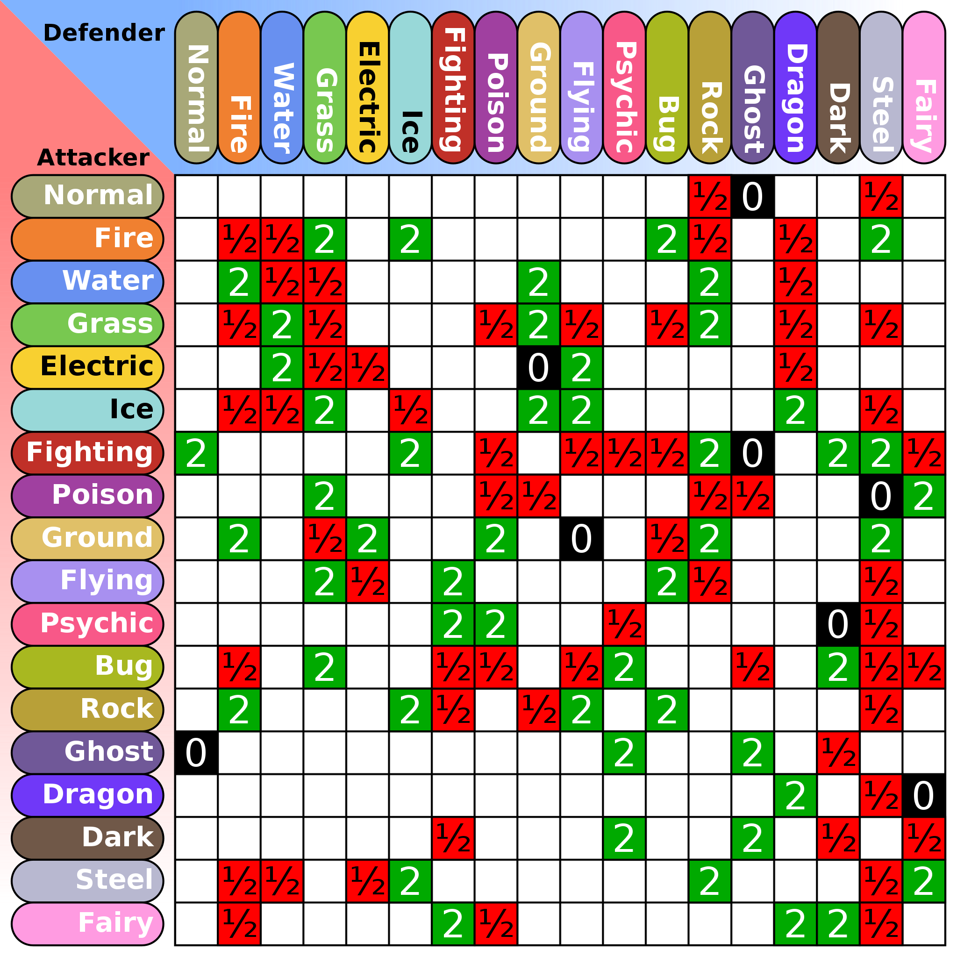

Speed Run Pokemon

<https://www.thegamer.com/pokemon-red-speedrunner-pokeguy-unbeatable-world-record/#:~:text=Reported%20by%20GamesRadar%2C%20pokeguy%20set,of%201%3A45%3A06>.

Speed Run Video

[Pokemon Red Any% Glitchless Speedrun in 1:45:21 [Former World Record]](https://www.youtube.com/watch?v=wwvgAAvhxM8)

Pokemon fire red

<https://gorilagames.com.br/download-pokemon-fire-red-celular-dicas/>

Speedrun Route

<https://pokemon-speedrunning.github.io/speedrun-routes/#/gen-1/red-blue/main-glitchless/beginner-route/nolass/?id=pokemon-red-glitchless-beginner-guide-no-lass-version>

Pokemon Fire Red Battle Engine

<https://github.com/Skeli789/Complete-Fire-Red-Upgrade>